

Lab Report on CSE 1204

**Submitted by Submitted to**

**Name**: Md. Shabir Khan Akash. Shyla Afroge

**Class**: 1st year, even semester. Assistant Professor

**Dept**.: Department of CSE Department of CSE, RUET

**Roll**: 1603108

**Section:** B

**Theory**

The single most important feature of C++ is the class. The class is a mechanism that is used to create objects. As such, the class is at the heart of many C++ features. A class is a keyword which is declared using ‘class’ . A class has class-name and its body. In the body, there may be variables , functions in different modes depending on the purpose of the program. Generally public and private are two types of mode that are used frequently. Public keyword is used to declare variable or functions in public mode followed by a colon. Class’s functions or variables are called by dot (.) operator by the object in the main function. That is how this class actually works.

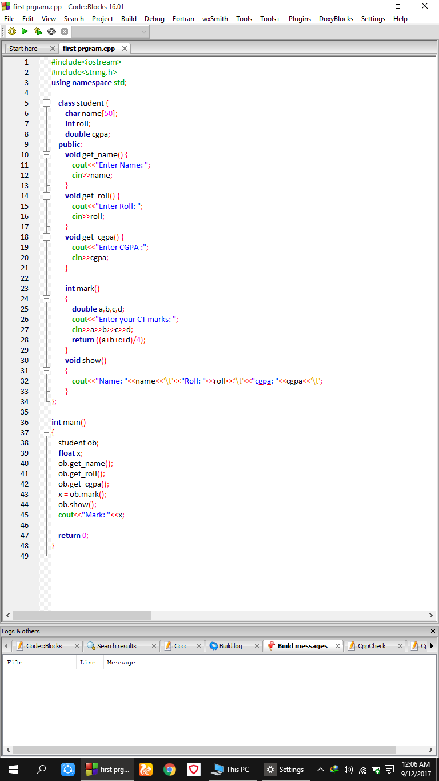**Code**

**Output**

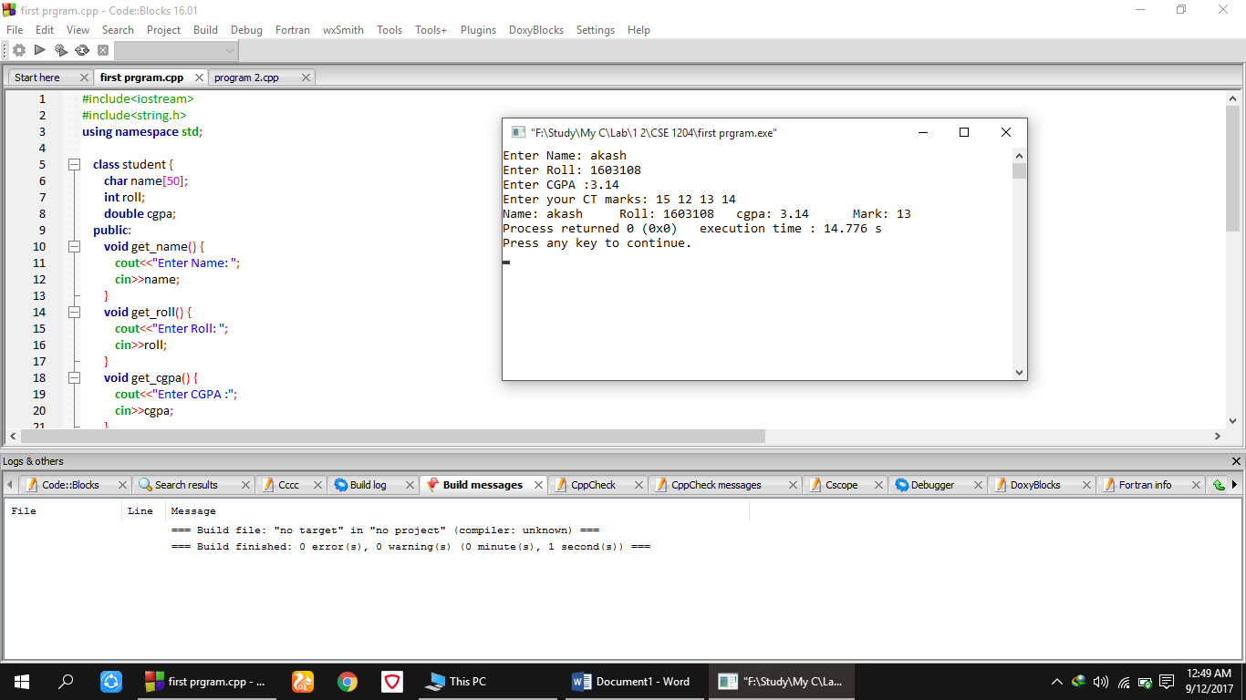

**Comment**

In the above code, a **class** named **student** was declared in the very beginning of the code. Then name, roll, cgpa, mark variables were declared for the items of information of a student that the program will work on. In this class, six functions named **get_name(), get_roll(), get_cgpa(), mark(), show(), show_mark()** were used in public mode. Then in main function an object named **ob** was declared and was called all those above six functions gradually and each of the functions executed in the class section and then was called in the main function by dot operator. This way the program ended.

**Theory**

Constructor function is a function of C++ which is to be included in a class declaration. A class’s constructor is called each time on object of that class is created. Thus any initializations that need to be performed on an object can be done automatically by the constructor function. The name of the constructor function of a program is same as the name of that program’s class name. It has no return type and it is a part of a class. When writing a program for very long and many parts are included in that program, constructor function is needed to initialize the objects.

A class’s destructor is called when an object is destroyed in the program. Destructor functions are called automatically at the end of the program. Local objects are destroyed when they go out of scope. Global objects are destroyed when the program ends.

**Code**

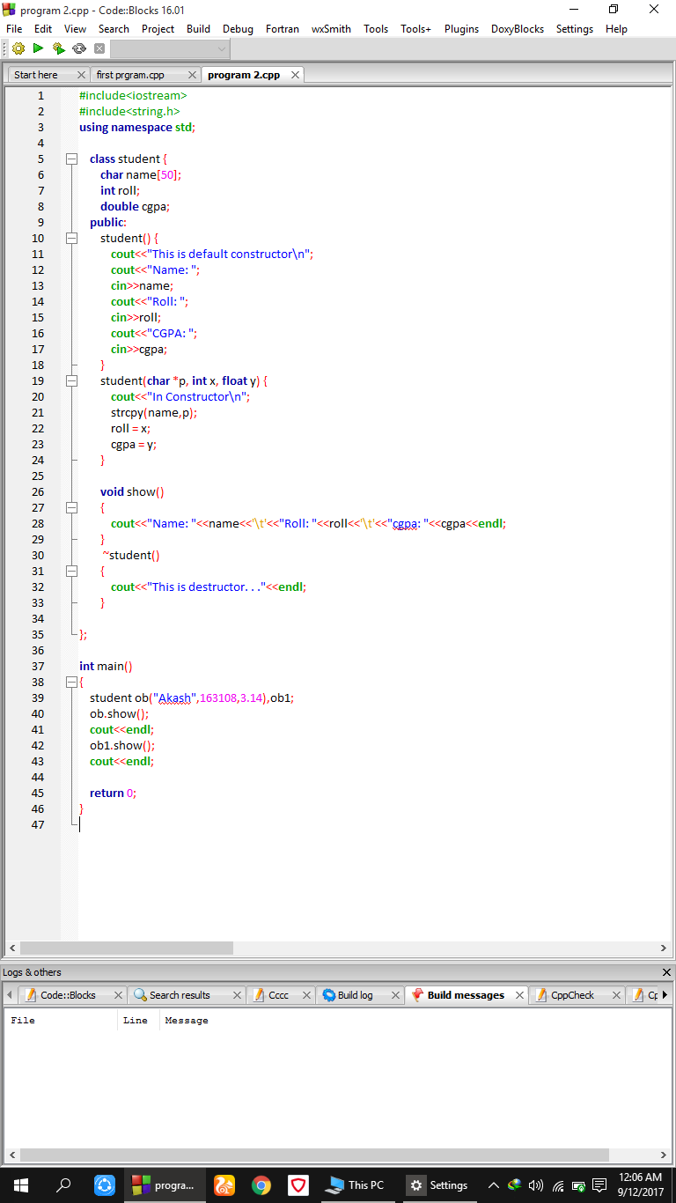

**Output**

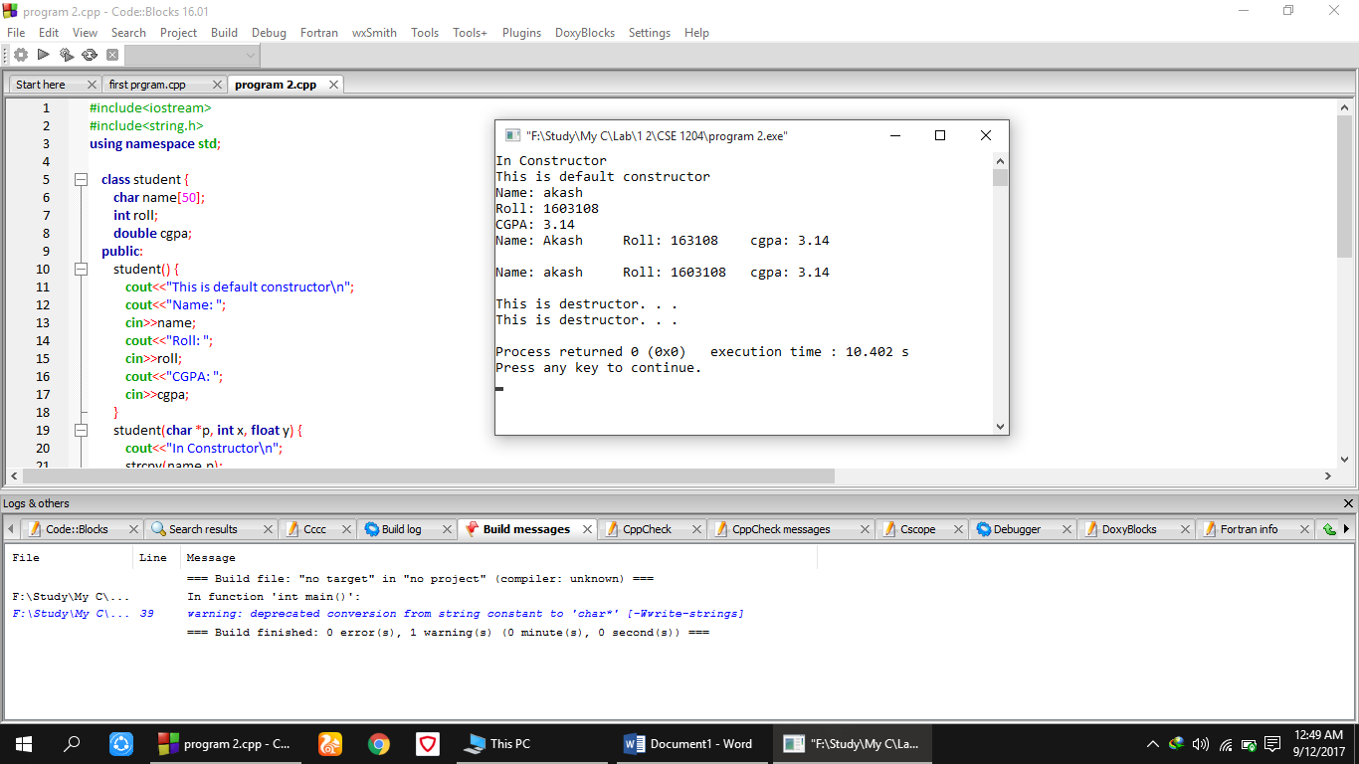

**Comment**

In this above code, a class named student was declared and in this class three data types (char , int , float) naming name , roll, cgpa was declared privately and in public mode , a function named student() was declared. This student function is the constructor function as it has no return type. In the constructor name, roll, cgpa of a student was taken from the user. Also note that this constructor is a part of student class. Then another constructor was declared with name, roll, cgpa being assigned in the program. Then in the end, in main fnction constructor was called and ~student() function was automatically called as it is known as the destructor function of this program.